The Unix operating system is a set of programs that act as a link between the computer and the user.

The computer programs that allocate the system resources and coordinate all the details of the computer's internals is called the **operating system** or the **kernel**.

Users communicate with the kernel through a program known as the **shell**. The shell is a command line interpreter; it translates commands entered by the user and converts them into a language that is understood by the kernel.

* Unix was originally developed in 1969 by a group of AT&T employees Ken Thompson, Dennis Ritchie, Douglas McIlroy, and Joe Ossanna at Bell Labs.
* There are various Unix variants available in the market. Solaris Unix, AIX, HP Unix and BSD are a few examples. Linux is also a flavor of Unix which is freely available.
* Several people can use a Unix computer at the same time; hence Unix is called a multiuser system.
* A user can also run multiple programs at the same time; hence Unix is a multitasking environment.

Unix Architecture

Here is a basic block diagram of a Unix system −

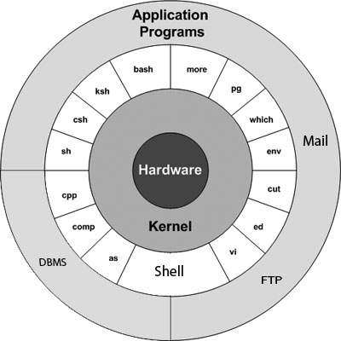

The main concept that unites all the versions of Unix is the following four basics −

* **Kernel** − The kernel is the heart of the operating system. It interacts with the hardware and most of the tasks like memory management, task scheduling and file management.
* **Shell** − The shell is the utility that processes your requests. When you type in a command at your terminal, the shell interprets the command and calls the program that you want. The shell uses standard syntax for all commands. C Shell, Bourne Shell and Korn Shell are the most famous shells which are available with most of the Unix variants.
* **Commands and Utilities** − There are various commands and utilities which you can make use of in your day to day activities. **cp**, **mv**, **cat** and **grep**, etc. are few examples of commands and utilities. There are over 250 standard commands plus numerous others provided through 3rd party software. All the commands come along with various options.
* **Files and Directories** − All the data of Unix is organized into files. All files are then organized into directories. These directories are further organized into a tree-like structure called the **filesystem**.

**What is UNIX?**

The UNIX OS was born in the late 1960s. AT&T Bell Labs released an operating system called Unix written in C, which allows quicker modification, acceptance, and portability.

It began as a one-man project under the leadership of Ken Thompson of Bell Labs. It went on to become most widely used operating systems. Unix is a proprietary operating system.

The Unix OS works on CLI (Command Line Interface), but recently, there have been developments for GUI on Unix systems. Unix is an OS which is popular in companies, universities big enterprises, etc.

**What is LINUX?**

Linux is an operating system built by Linus Torvalds at the University of Helsinki in 1991. The name "Linux" comes from the Linux kernel. It is the software on a computer which enables applications and the users to access the devices on the computer to perform some specific function.

The Linux OS relays instructions from an application from the computer's processor and sends the results back to the application via the Linux OS. It can be installed on a different type of computers mobile phones, tablets video game consoles, etc.

Learn Java Programming with Beginners Tutorial

The development of Linux is one of the most prominent examples of free and open source software collaboration. Today many companies and similar numbers of individuals have released their own version of OS based on the Linux Kernel.

**KEY DIFFERENCE**

* Linux source code is available to the general public whereas, in Unix, the source code is proprietary.
* UNIX OS was created in the late 1960s at AT&T Bell Labs whereas Linux is an operating system built by Linus Torvalds at the University of Helsinki in 1991.
* Linux is a clone of Unix
* Linux default shell is BASH while the Unix shell is Bourne Shell.
* Linux threat detection and solution are very fast while Unix users require longer wait times to get the proper bug fixing patch.
* Important versions of Linux are Redhat, Ubuntu, OpenSuse, Solaris, whereas important versions of Unix are HP-UX, AIS, BSD, etc.

**Features of Unix OS**

* Multi-user, multitasking operating system
* It can be used as the master control program in workstations and servers.
* Hundreds of commercial applications are available
* In its heydays, UNIX was rapidly adopted and became the standard OS in universities.

**Features of Linux Operating System**

* Support multitasking
* Programs consist of one or more processes, and each process have one or more threads
* It can easily co-exists along with other Operating systems.
* It can run multiple user programs
* Individual accounts are protected because of appropriate authorization
* Linux is a replica of UNIX but does not use its code.

# Linux Commands with Examples

The Linux command is a utility of the Linux operating system. All basic and advanced tasks can be done by executing commands. The commands are executed on the **Linux terminal**. The terminal is a command-line interface to interact with the system, which is similar to the command prompt in the Windows OS. Commands in Linux are ***case-sensitive***.

[Linux](https://www.javatpoint.com/linux-tutorial) provides a powerful command-line interface compared to other operating systems such as [Windows](https://www.javatpoint.com/windows) and MacOS. We can do basic work and advanced work through its terminal. We can do some basic tasks such as creating a file, deleting a file, moving a file, and more. In addition, we can also perform advanced tasks such as administrative tasks (including package installation, user management), networking tasks (ssh connection), security tasks, and many more.

Linux terminal is a user-friendly terminal as it provides various support options. To open the Linux terminal, press "**CTRL + ALT + T**" keys together, and execute a command by pressing the '**ENTER**' key.

### Linux Directory Commands

**1. pwd Command**

The [pwd](https://www.javatpoint.com/linux-pwd) command is used to display the location of the current working directory.

**Syntax:**

1. pwd

**Output:**

Linux Commands with Examples

**2. mkdir Command**

The [mkdir](https://www.javatpoint.com/linux-mkdir) command is used to create a new directory under any directory.

**Syntax:**

1. mkdir **<directory** name**>**

**Output:**

Linux Commands with Examples

**3. rmdir Command**

The [rmdir](https://www.javatpoint.com/linux-rmdir) command is used to delete a directory.

**Syntax:**

1. rmdir **<directory** name**>**

**Output:**

Linux Commands with Examples

**4. ls Command**

The [ls](https://www.javatpoint.com/linux-ls) command is used to display a list of content of a directory.

**Syntax:**

1. ls

**Output:**

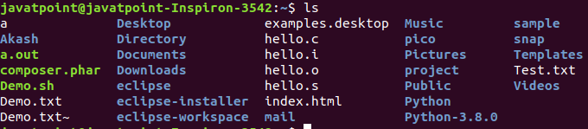

**5. cd Command**

The [cd](https://www.javatpoint.com/linux-cd) command is used to change the current directory.

**Syntax:**

1. cd **<directory** name**>**

**Output:**

Linux Commands with Examples

### Linux File commands

**6. touch Command**

The [touch](https://www.javatpoint.com/linux-touch) command is used to create empty files. We can create multiple empty files by executing it once.

**Syntax:**

1. touch **<file** name**>**
2. touch **<file1>**  **<file2>** ....

**Output:**

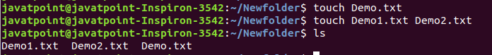

**7. cat Command**

The [cat](https://www.javatpoint.com/linux-cat) command is a multi-purpose utility in the Linux system. It can be used to create a file, display content of the file, copy the content of one file to another file, and more.

**Syntax:**

1. cat [OPTION]... [FILE]..

To create a file, execute it as follows:

1. cat **>** **<file** name**>**
2. // Enter file content

Press "**CTRL+ D**" keys to save the file. To display the content of the file, execute it as follows:

1. cat **<file** name**>**

**Output:**

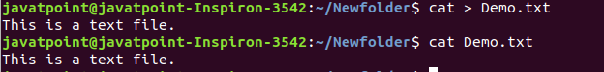

**8. rm Command**

The [rm](https://www.javatpoint.com/linux-rm) command is used to remove a file.

**Syntax:**

rm <file name>

**Output:**

Linux Commands with Examples

**9. cp Command**

The [cp](https://www.javatpoint.com/linux-cp) command is used to copy a file or directory.

**Syntax:**

To copy in the same directory:

1. cp **<existing** file name**>** **<new** file name**>**

To copy in a different directory:

**Output:**

Linux Commands with Examples

**10. mv Command**

The [mv](https://www.javatpoint.com/linux-mv) command is used to move a file or a directory form one location to another location.

**Syntax:**

1. mv **<file** name**>** **<directory** path**>**

**Output:**

Linux Commands with Examples

**11. rename Command**

The [rename](https://www.javatpoint.com/linux-rename) command is used to rename files. It is useful for renaming a large group of files.

**Syntax:**

1. rename 's/old-name/new-name/' files

For example, to convert all the text files into pdf files, execute the below command:

1. rename 's/\.txt$/\.pdf/' *.txt

**Output:**

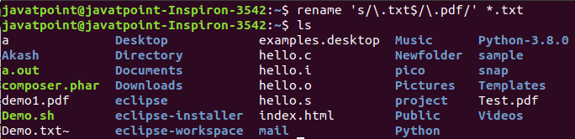

### Linux File Content Commands

**12. head Command**

The [head](https://www.javatpoint.com/linux-head) command is used to display the content of a file. It displays the first 10 lines of a file.

**Syntax:**

1. head **<file** name**>**

**Output:**

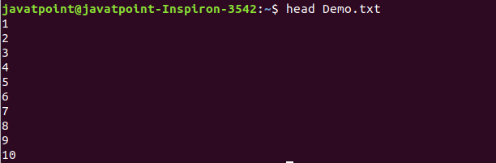

**13. tail Command**

The [tail](https://www.javatpoint.com/linux-tail) command is similar to the head command. The difference between both commands is that it displays the last ten lines of the file content. It is useful for reading the error message.

**Syntax:**

1. tail **<file** name**>**

**Output:**

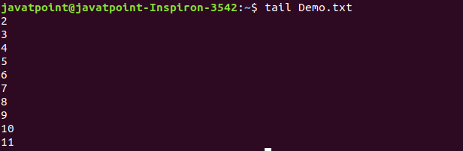

**14. tac Command**

The [tac](https://www.javatpoint.com/linux-tac) command is the reverse of cat command, as its name specified. It displays the file content in reverse order (from the last line).

**Syntax:**

1. tac **<file** name**>**

**Output:**

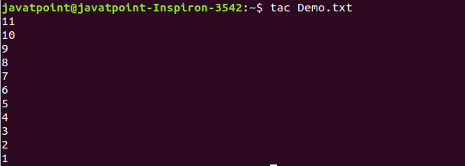

**15. more command**

The [more](https://www.javatpoint.com/linux-more) command is quite similar to the cat command, as it is used to display the file content in the same way that the cat command does. The only difference between both commands is that, in case of larger files, the more command displays screenful output at a time.

In more command, the following keys are used to scroll the page:

**ENTER key:** To scroll down page by line.

**Space bar:** To move to the next page.

**b key:** To move to the previous page.

**/ key:** To search the string.

**Syntax:**

1. more **<file** name**>**

**Output:**

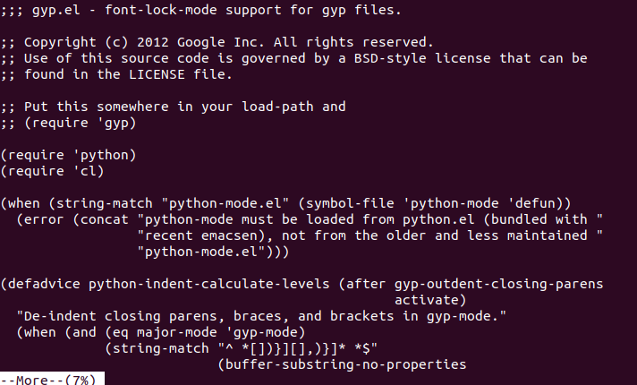

**16. less Command**

The [less](https://www.javatpoint.com/linux-less) command is similar to the more command. It also includes some extra features such as 'adjustment in width and height of the terminal.' Comparatively, the more command cuts the output in the width of the terminal.

**Syntax:**

1. less **<file** name**>**

**Output:**

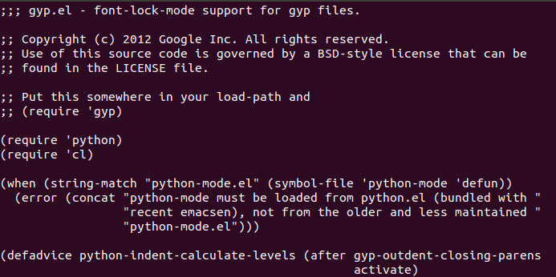

### Linux User Commands

**17. su Command**

The [su](https://www.javatpoint.com/linux-su-commands) command provides administrative access to another user. In other words, it allows access of the Linux shell to another user.

**Syntax:**

1. su **<user** name**>**

**Output:**

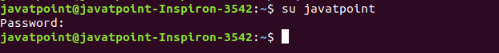

**18. id Command**

The [id](https://www.javatpoint.com/linux-id-command) command is used to display the user ID (UID) and group ID (GID).

**Syntax:**

1. id

**Output:**

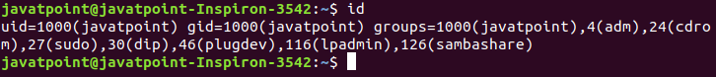

**19. useradd Command**

The [useradd](https://www.javatpoint.com/linux-create-user) command is used to add or remove a user on a Linux server.

**Syntax:**

1. useradd  username

**Output:**

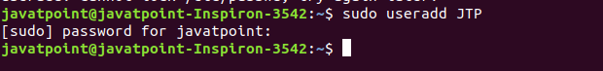

**20. passwd Command**

The [passwd](https://www.javatpoint.com/linux-user-password) command is used to create and change the password for a user.

**Syntax:**

1. passwd **<username>**

**Output:**

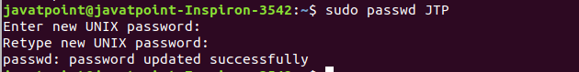

**21. groupadd Command**

The [groupadd](https://www.javatpoint.com/linux-add-user-to-group) command is used to create a user group.

**Syntax:**

1. groupadd **<group** name**>**

**Output:**

### Linux Commands with Examples

### Linux Filter Commands

**22. cat Command**

The [cat](https://www.javatpoint.com/linux-cat-filters) command is also used as a filter. To filter a file, it is used inside pipes.

**Syntax:**

1. cat **<fileName>** | cat or tac | cat or tac |. . .

**Output:**

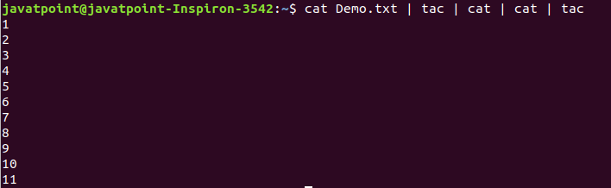

**23. cut Command**

The [cut](https://www.javatpoint.com/linux-cut) command is used to select a specific column of a file. The '-d' option is used as a delimiter, and it can be a space (' '), a slash (/), a hyphen (-), or anything else. And, the '-f' option is used to specify a column number.

**Syntax:**

1. cut -d(delimiter) -f(columnNumber) **<fileName>**

**Output:**

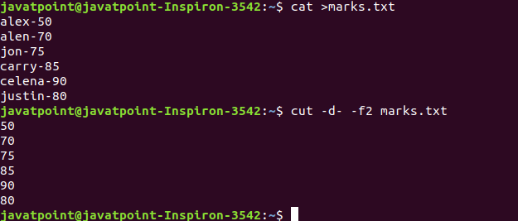

**24. grep Command**

The [grep](https://www.javatpoint.com/linux-grep) is the most powerful and used filter in a Linux system. The 'grep' stands for "**global regular expression print**." It is useful for searching the content from a file. Generally, it is used with the pipe.

**Syntax:**

1. command | grep **<searchWord>**

**Output:**

Linux Commands with Examples

**25. comm Command**

The ['comm'](https://www.javatpoint.com/linux-comm) command is used to compare two files or streams. By default, it displays three columns, first displays non-matching items of the first file, second indicates the non-matching item of the second file, and the third column displays the matching items of both files.

**Syntax:**

1. comm **<file1>** **<file2>**

**Output:**

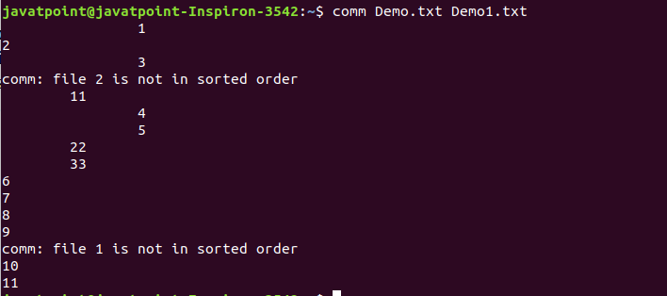

**26. sed command**

The [sed](https://www.javatpoint.com/linux-sed) command is also known as **stream editor**. It is used to edit files using a regular expression. It does not permanently edit files; instead, the edited content remains only on display. It does not affect the actual file.

**Syntax:**

1. command | sed 's/**<oldWord>**/**<newWord>**/'

**Output:**

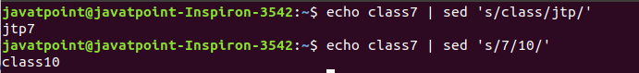

**27. tee command**

The [tee](https://www.javatpoint.com/linux-tee) command is quite similar to the cat command. The only difference between both filters is that it puts standard input on standard output and also write them into a file.

**Syntax:**

1. cat **<fileName>** | tee **<newFile>** |  cat or tac |.....

**Output:**

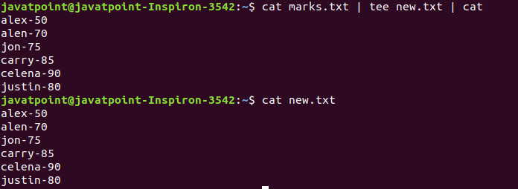

**28. tr Command**

The [tr](https://www.javatpoint.com/linux-tr) command is used to translate the file content like from lower case to upper case.

**Syntax:**

1. command | tr **<**'old'**>** **<**'new'**>**

**Output:**

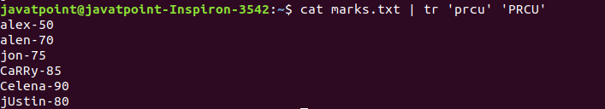

**29. uniq Command**

The [uniq](https://www.javatpoint.com/linux-uniq) command is used to form a sorted list in which every word will occur only once.

**Syntax:**

1. command **<fileName>** | uniq

**Output:**

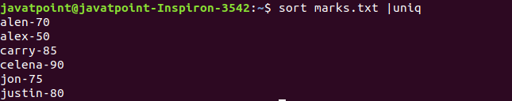

**30. wc Command**

The [wc](https://www.javatpoint.com/linux-wc) command is used to count the lines, words, and characters in a file.

**Syntax:**

1. wc **<file** name**>**

**Output:**

Linux Commands with Examples

**31. od Command**

The [od](https://www.javatpoint.com/linux-od) command is used to display the content of a file in different s, such as hexadecimal, octal, and ASCII characters.

**Syntax:**

1. od -b **<fileName>**      // Octal format
2. od -t x1 **<fileName>**   // Hexa decimal format
3. od -c **<fileName>**     // ASCII character format

**Output:**

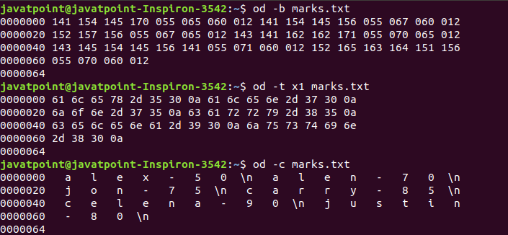

**32. sort Command**

The [sort](https://www.javatpoint.com/linux-sort) command is used to sort files in alphabetical order.

**Syntax:**

1. sort **<file** name**>**

**Output:**

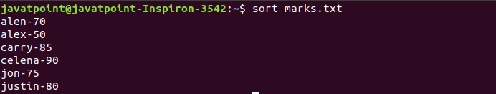

**33. gzip Command**

The [gzip](https://www.javatpoint.com/linux-gzip) command is used to truncate the file size. It is a compressing tool. It replaces the original file by the compressed file having '.gz' extension.

**Syntax:**

1. gzip **<file1>** **<file2>** **<file3>**...

**Output:**

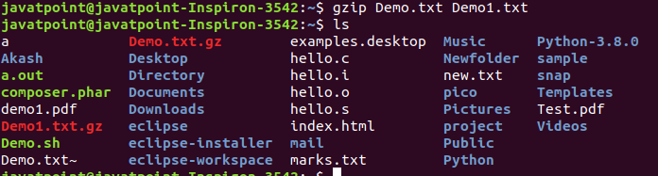

**34. gunzip Command**

The [gunzip](https://www.javatpoint.com/linux-gzip) command is used to decompress a file. It is a reverse operation of gzip command.

**Syntax:**

1. gunzip **<file1>** **<file2>** **<file3>**. .

**Output:**

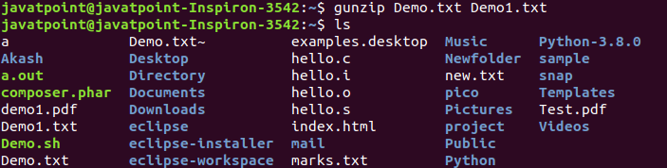

### Linux Utility Commands

**35. find Command**

The [find](https://www.javatpoint.com/linux-find) command is used to find a particular file within a directory. It also supports various options to find a file such as byname, by type, by date, and more.

The following symbols are used after the find command:

(.) : For current directory name

(/) : For root

**Syntax:**

1. find . -name "*.pdf"

**Output:**

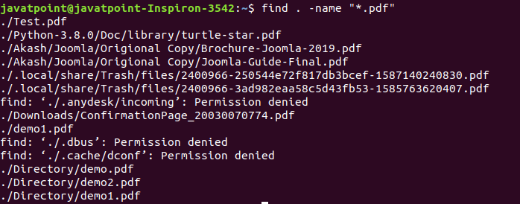

**36. locate Command**

The [locate](https://www.javatpoint.com/linux-locate) command is used to search a file by file name. It is quite similar to find command; the difference is that it is a background process. It searches the file in the database, whereas the find command searches in the file system. It is faster than the find command. To find the file with the locates command, keep your database updated.

**Syntax:**

1. locate **<file** name**>**

**Output:**

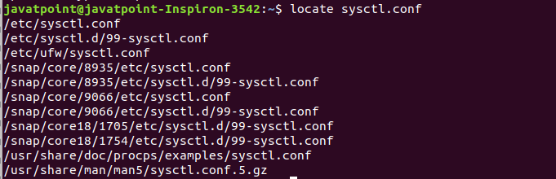

**37. date Command**

The [date](https://www.javatpoint.com/linux-date) command is used to display date, time, time zone, and more.

**Syntax:**

1. date

**Output:**

Linux Commands with Examples

**38. cal Command**

The [cal](https://www.javatpoint.com/linux-cal) command is used to display the current month's calendar with the current date highlighted.

**Syntax:**

1. cal**<**

**Output:**

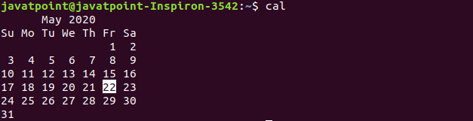

**39. sleep Command**

The [sleep](https://www.javatpoint.com/linux-sleep) command is used to hold the terminal by the specified amount of time. By default, it takes time in seconds.

**Syntax:**

1. sleep **<time>**

**Output:**

Linux Commands with Examples

**40. time Command**

The [time](https://www.javatpoint.com/linux-time) command is used to display the time to execute a command.

**Syntax:**

1. time

**Output:**

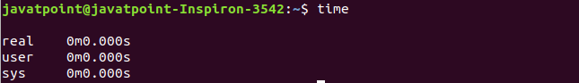

**41. zcat Command**

The zcat command is used to display the compressed files.

**Syntax:**

1. zcat **<file** name**>**

**Output:**

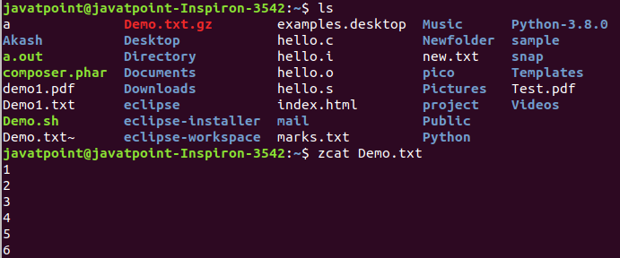

**42. df Command**

The [df](https://www.javatpoint.com/linux-df) command is used to display the disk space used in the file system. It displays the output as in the number of used blocks, available blocks, and the mounted directory.

**Syntax:**

1. df

**Output:**

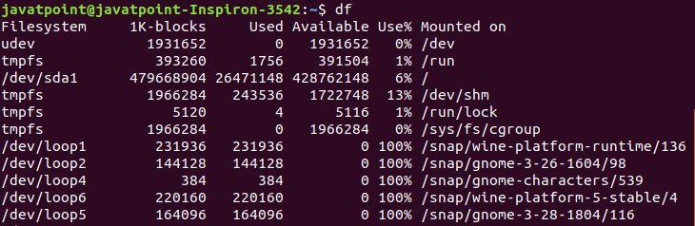

**43. mount Command**

The [mount](https://www.javatpoint.com/linux-mount) command is used to connect an external device file system to the system's file system.

**Syntax:**

1. mount -t type **<device>** **<directory>**

**Output:**

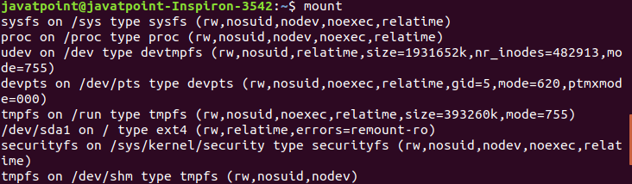

**44. exit Command**

Linux [exit](http://javatpoint.com/linux-exit-command) command is used to exit from the current shell. It takes a parameter as a number and exits the shell with a return of status number.

**Syntax:**

1. exit

**Output:**

Linux Commands with Examples

After pressing the ENTER key, it will exit the terminal.

**45. clear Command**

Linux **clear** command is used to clear the terminal screen.

**Syntax:**

1. clear

**Output:**

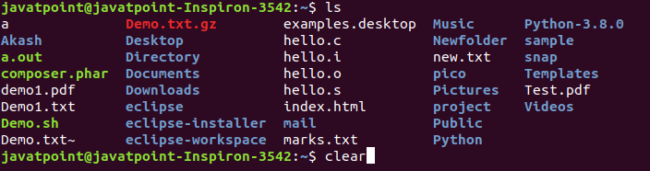

After pressing the ENTER key, it will clear the terminal screen.

### Linux Networking Commands

**46. ip Command**

Linux [ip](https://www.javatpoint.com/linux-ip) command is an updated version of the ipconfig command. It is used to assign an IP address, initialize an interface, disable an interface.

**Syntax:**

1. ip a or ip addr

**Output:**

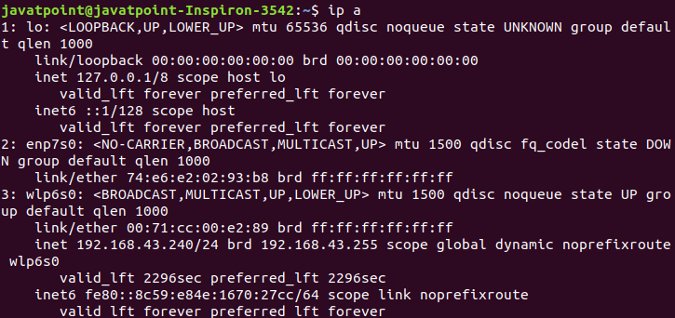

**47. ssh Command**

Linux [ssh](https://www.javatpoint.com/ssh-linux) command is used to create a remote connection through the ssh protocol.

**Syntax:**

1. ssh user_name@host(IP/Domain_name)**</p>**

**48. mail Command**

The [mail](https://www.javatpoint.com/linux-mail-command) command is used to send emails from the command line.

**Syntax:**

1. mail -s "Subject" **<recipient** address**>**

**Output:**



**49. ping Command**

The [ping](https://www.javatpoint.com/linux-ping) command is used to check the connectivity between two nodes, that is whether the server is connected. It is a short form of "Packet Internet Groper."

**Syntax:**

1. ping **<destination>**

**Output:**

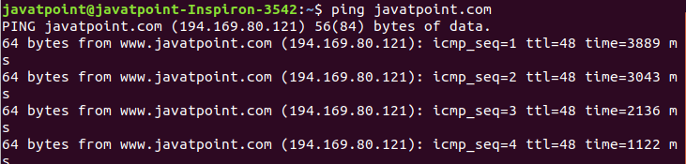

**50. host Command**

The [host](https://www.javatpoint.com/linux-host) command is used to display the IP address for a given domain name and vice versa. It performs the DNS lookups for the DNS Query.

**Syntax:**

1. host **<domain** name**>** or **<ip** address**>**

**Output:**

Linux Commands with Examples

# Linux Introduction To Users

This tutorial will tell you how to identify a system's user account with commands like who, who am i, etc.

If more than one person use a single system, then everyone may have their own user account. Here, it will be helpful to know the user account details.

It also tells how to create a second user account and run program on that with the help of su and sudo command.

## whoami

It tells you about the system's username.

**Syntax:**

1. whoami

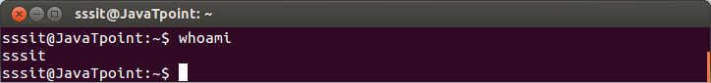

Look at the above snapshot, **'sssit'** is our system's username.

## who

The who command gives the information about the users logged on to the system.

**Syntax:**

1. who

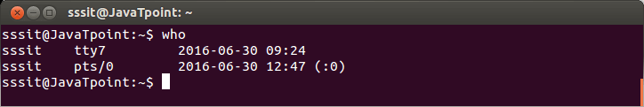

## who am i

This command displays the information about the current user only.

**Syntax:**

1. who am i

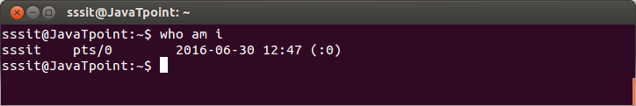

Look at the above snapshot, in our system current logged in user is **sssit**.

## w

This command tells about the users who are logged in and what are they doing.

**Syntax:**

1. w

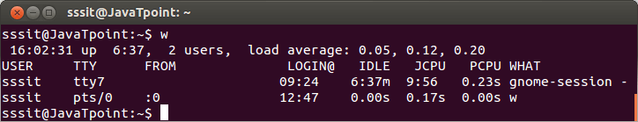

## id

This command tells about your user id, primary group id, and a list of groups that belongs to you.

**Syntax:**

1. id

# Linux Introduction To Users5 Linux Create User | Linux Add user | Linux user add command

The Linux server allows us to create more than one user after installation. Linux is a Multi-user system, which means more than one user can work in the same system at the same time. We are allowed to do so through the Setup agent.

We must have to create an account in order to work with [Linux](https://www.javatpoint.com/linux-tutorial) as we cannot keep working with the root account. We have one administrative account; a system administrator account is responsible for managing the user accounts and groups of the system.

Adding or removing a user is one of the most basic tasks of a new Linux server.

We are given only a root user account by a new Linux server. Adding a user account provides lots of power and accessibility to a particular user. It is a useful but insecure utility of the Linux server. It is good to add an unprivileged user to do common tasks. However, we can access the administrative privilege through sudo command-line utility.

## Create User in Linux (Ubuntu)

There are two most common ways to add a user to a Linux server.

* **Graphically through user manager**
* **By the useradd command (Terminal)**

### 1. By Graphically through user manager

Linux [GUI](https://www.javatpoint.com/gui-full-form) allows us to create a user from its functions. It is a straight forward process. To create a user to your Linux server, follow the below steps:

**Step1:** Goto system search and search for the **setting** and navigate to **Detail-> About.**

**Step2:** Click on the **Users** after that **Unlock option** given on the header. It will ask for the system security password to enter the password and click **ok** to continue. Consider the below image:

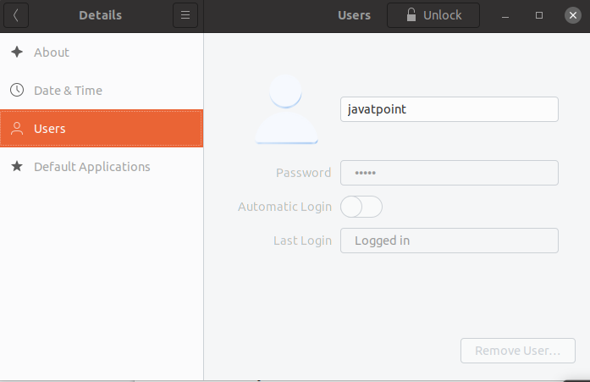

**Step3:** Click on the **Add User** option to add a new user.

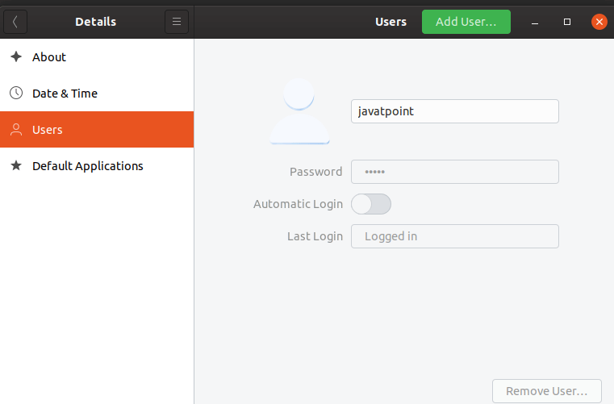

**Step4:** Enter the user details like username and password and account type. We can create two types of accounts, which are Standard and Administrator. The standard account does not contain the sudo privilege. However, we can provide it later.

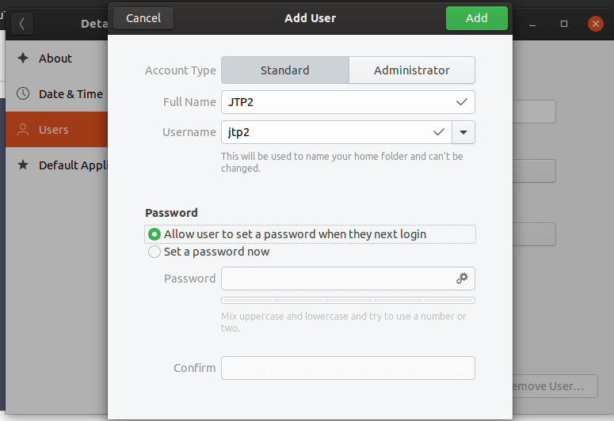

**Step5:** Now, we have successfully created a new user called JTP2. Consider the below image.

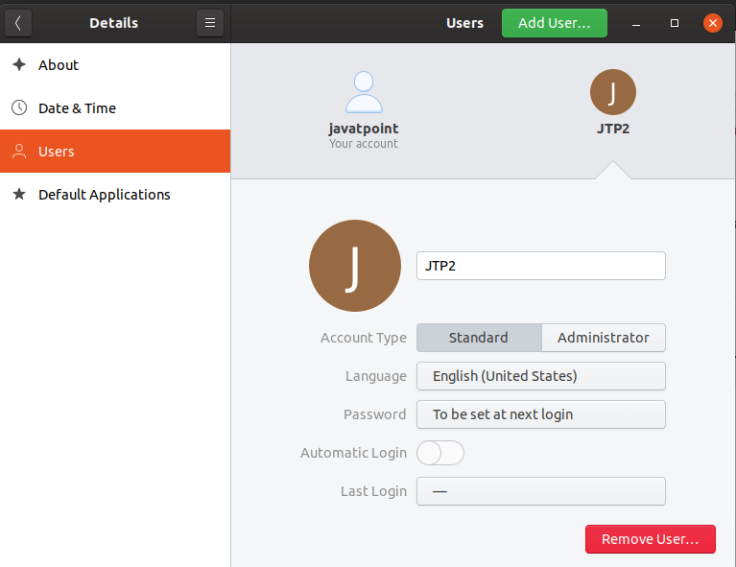

### 2. By the Linux useradd command

In Linux, **useradd command**is a command-line utility which is used to add or remove a user on a Linux server and Unix based operating system.

In a different type of Linux distribution, the useradd command may be slightly different.

The useradd command performs the below tasks:

* It edits the files for newly created user like **/etc/passwd**, **/etc/shadow**, **/etc/group** and **/etc/gshadow.**
* It creates and opens a new home directory.
* It allows us to set ownerships and permissions to the home directory.

**Syntax:**

1. useradd [options] username

In order to use the useradd command, we have to log-in with root or sudo access.

Before using Linux useradd command, let's understand some common terms that are used in the Linux command line.

* **Username**: A username is a name that is used to login to the Linux system. It is displayed when we turn on our machine. The username length should be between 1 to 32 characters.

**Password:** A password is a secret code that is used to protect your system from unauthorized access. It is stored in etc/shadow file in an encrypted format.

**User ID (UID)**: Linux provide a unique Id to every user; it is called **user identification number** or **User ID** or **UID**. By default, the UID for the root user is reserved as zero, and the remaining UID from 1 to 99 is reserved for other predefined accounts. Further, UID's from 100-999 are reserved for groups and system accounts.

**Group ID (GID):** The GID or Group ID is a group identification number provided by the Linux system. It is stored in **/etc/group** file.

**User Info:** It allows us to define some additional information about the user, such as user full name. It is optional.

**Home Directory:** It is an absolute location for a user.

**Shell:** It is an absolute location of a user's shell i.e. /bin/bash.

To create a new user by useradd command, execute the useradd command followed by username as follows:

1. sudo useradd JTP3

The above command will ask for the system administration password, enter the password. It will create a user named as JTP3. This username is used by the user to login the system. The username must be unique. Consider the below output:

Linux Create User

To set the password for the newly created user, execute the below command:

1. sudo passwd JTP3

The above command will ask for the new password, enter the password and retype the new password. It will update the password for the specified user. Consider the below output:

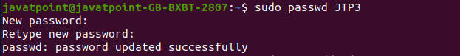

### Create a user with a home directory

Sometimes the newly created user may or may not assign a home directory. To create a user and to forcefully assign a home directory to it, execute the below command:

1. sudo useradd -m Demo

Consider the below snap of terminal:

Linux Create User

The above command will ask for the system administration password and create a directory **home/Demo** for the user **Demo.**

### Create a user with a different home directory

Linux allows us to create a home directory on a different place instead of the default folder. Use the -d option with useradd command to create a different home directory. Execute the below command:

1. sudo useradd -m -d /Demo1 Demo1

The above command will create a Demo1 folder under the root directory for the user Demo1. Consider the below snap of the terminal:

Linux Create User

### Create a user with an expiry date

To create a user with an expiry date that means after a particular date, it will be auto-deleted.

1. sudo useradd -d /home/test -e 2020-03-16 Demo2

The above command will create a user with a specified expiry date. It will create a user named Demo2, which will be auto-deleted after 16 March 2020. Consider the below snap of the terminal:

Linux Create User

It will be useful when you want to create an account for any user who is going to depart after a short period.

.

|  |  |
| --- | --- |
| **Year** | **Event** |
| **1957** | Bell Labs found they needed an operating system for their computer center which at the time was running various batch jobs. The BESYS operating system was created at Bell Labs to deal with these needs. |
| **1965** | Bell Labs was adopting third generation computer equipment and decided to join forces with General Electric and MIT to create Multics (Multiplexed Information and Computing Service). |
| **1969** | By April 1969, [AT&T](https://www.landley.net/history/mirror/comp/att.htm) made a decision to withdraw Multics and go with GECOS. When Multics was withdrawn Ken Thompson and Dennis Ritchie needed to rewrite an operating system in order to play space travel on another smaller machine (a DEC PDP-7 [Programmed Data Processor 4K memory for user programs). The result was a system which a punning colleague called UNICS (UNiplexed Information and Computing Service)--an 'emasculated Multics'. |
| **1969** | Summer 1969 UNIX was developed. |
| **1971** | First edition of [UNIX](https://www.landley.net/history/mirror/unix/unix.htm) released 11/03/1971. The first edition of the "UNIX PROGRAMMER'S MANUAL [by] K. Thompson [and] D. M. Ritchie" is also dated "November 3, 1971". It includes over 60 commands like: b (compile B program); boot (reboot system); [**cat**](https://www.landley.net/history/mirror/unix/ucat.htm) (concatenate files); **[chdir](https://www.landley.net/history/mirror/unix/uchdir.htm)** (change working directory); **[chmod](https://www.landley.net/history/mirror/unix/uchmod.htm)** (change access mode); **[chown](https://www.landley.net/history/mirror/unix/uchown.htm)** (change owner); [**cp**](https://www.landley.net/history/mirror/unix/ucp.htm) (copy file); **[ls](https://www.landley.net/history/mirror/unix/uls.htm)** (list directory contents); **[mv](https://www.landley.net/history/mirror/unix/umv.htm)** (move or rename file); roff (run off text); **[wc](https://www.landley.net/history/mirror/unix/uwc.htm)** (get word count); [**who**](https://www.landley.net/history/mirror/unix/uwho.htm) (who is one the system). The main thing missing was pipes. |
| **1972** | Second edition of [UNIX](https://www.landley.net/history/mirror/unix/unix.htm) released 12/06/1972 |
| **1972** | Ritchie rewrote B and called the new language C. |
| **1973** | [UNIX](https://www.landley.net/history/mirror/unix/unix.htm) had been installed on 16 sites (all within AT&T/Western Electric); it was publically unveiled at a conference in October. |
| **1973** | Third edition of [UNIX](https://www.landley.net/history/mirror/unix/unix.htm) released 02/xx/1973 |
| **1973** | Forth edition of [UNIX](https://www.landley.net/history/mirror/unix/unix.htm) released 11/xx/1973 |
| **1974** | Fifth edition of [UNIX](https://www.landley.net/history/mirror/unix/unix.htm) released 06/xx/1974 |

## Linux Basic Commands

Before we go on to the list of commands, you need to open the command line first. If you are still unsure about the command-line interface, check out this [**CLI tutorial**](https://www.hostinger.com/tutorials/what-is-cli).

Although the steps may differ depending on the distribution that you’re using, you can usually find the command line in the **Utilities** section.

Here is a list of basic Linux commands:

### 1. pwd command

Use the **pwd** command to find out the path of the current working directory (folder) you’re in. The command will return an absolute (full) path, which is basically a path of all the directories that starts with a forward slash **(/)**. An example of an absolute path is **/home/username**.

### 2. cd command

To navigate through the Linux files and directories, use the **cd** command. It requires either the full path or the name of the directory, depending on the current working directory that you’re in.

Let’s say you’re in **/home/username/Documents** and you want to go to **Photos**, a subdirectory of **Documents**. To do so, simply type the following command: **cd** **Photos**.

Another scenario is if you want to switch to a completely new directory, for example,**/home/username/Movies**. In this case, you have to type **cd** followed by the directory’s absolute path: **cd /home/username/Movies**.

There are some shortcuts to help you navigate quickly:

* **cd ..** (with two dots) to move one directory up
* **cd**to go straight to the home folder
* **cd-** (with a hyphen) to move to your previous directory

On a side note, Linux’s shell is case sensitive. So, you have to type the name’s directory exactly as it is.

|  |  |
| --- | --- |
| ***cd ~*** | This command also changes the directory to home directory |
| ***cd /*** | Changes the directory to root directory |
| ***cd ..*** | Changes the directory to its parent directory |
| ***cd ‘xx yy’*** | We specify the folder name in inverted commas because there is a space in the folder name |

### 3. ls command

The**ls** command is used to view the contents of a directory. By default, this command will display the contents of your current working directory.

If you want to see the content of other directories, type **ls** and then the directory’s path. For example, enter **ls** **/home/username/Documents** to view the content of **Documents**.

There are variations you can use with the **ls** command:

* **ls -R** will list all the files in the sub-directories as well
* **ls -a** will show the hidden files
* **ls -al** will list the files and directories with detailed information like the permissions, size, owner, etc.

### 4. cat command

**cat** (short for concatenate) is one of the most frequently used commands in Linux. It is used to list the contents of a file on the standard output (sdout). To run this command, type **cat** followed by the file’s name and its extension. For instance: **cat file.txt**.

Here are other ways to use the **cat** command:

* **cat > filename**creates a new file
* **cat filename1 filename2>filename3**joins two files (1 and 2) and stores the output of them in a new file (3)
* to convert a file to upper or lower case use, **cat filename | tr a-z A-Z >output.txt**

|  |  |
| --- | --- |
| ***cat -b*** | This is used to add line numbers to non-blank lines |
| ***cat -n*** | This is used to add line numbers to all lines |
| ***cat -s*** | This is used to squeeze blank lines into one line |
| ***cat –E*** | Show $ at the end of line |

### 5. cp command

Use the **cp** command to copy files from the current directory to a different directory. For instance, the command **cp scenery.jpg** **/home/username/Pictures** would create a copy of **scenery.jpg** (from your current directory) into the **Pictures** directory.

### 6. mv command

The primary use of the **mv** command is to move files, although it can also be used to rename files.

The arguments in mv are similar to the cp command. You need to type **mv**, the file’s name, and the destination’s directory. For example: **mv file.txt /home/username/Documents**.

To rename files, the Linux command is **mv oldname.ext newname.ext**

### 7. mkdir command

Use **mkdir** command to make a new directory — if you type **mkdir Music** it will create a directory called **Music**.

There are extra **mkdir** commands as well:

* To generate a new directory inside another directory, use this Linux basic command **mkdir Music/Newfile**
* use the **p**(parents) option to create a directory in between two existing directories. For example, **mkdir -p Music/2020/Newfile** will create the new “2020” file.

### 8. rmdir command

If you need to delete a directory, use the **rmdir** command. However, rmdir only allows you to delete empty directories.

### 9. rm command

The **rm** command is used to delete directories and the contents within them. If you only want to delete the directory — as an alternative to rmdir — use **rm -r**.

**Note**: Be very careful with this command and double-check which directory you are in. This will delete everything and there is no undo.

### 10. touch command

The **touch** command allows you to create a blank new file through the Linux command line. As an example, enter touch **/home/username/Documents/Web.html** to create an HTML file entitled **Web** under the **Documents** directory.

### 11. locate command

You can use this command to **locate** a file, just like the search command in Windows. What’s more, using the **-i** argument along with this command will make it case-insensitive, so you can search for a file even if you don’t remember its exact name.

To search for a file that contains two or more words, use an asterisk **(*)**. For example, **locate -i school*note** command will search for any file that contains the word “school” and “note”, whether it is uppercase or lowercase.

### 12. find command

Similar to the **locate** command, using **find** also searches for files and directories. The difference is, you use the **find** command to locate files within a given directory.

As an example, find **/home/ -name notes.txt** command will search for a file called **notes.txt** within the home directory and its subdirectories.

Other variations when using the **find** are:

* To find files in the current directory use, **find . -name notes.txt**
* To look for directories use, **/ -type d -name notes. txt**

### 13. grep command

Another basic Linux command that is undoubtedly helpful for everyday use is **grep**. It lets you search through all the text in a given file.

To illustrate, **grep blue notepad.txt** will search for the word blue in the notepad file. Lines that contain the searched word will be displayed fully.

|  |  |
| --- | --- |
| ***grep -i*** | Returns the results for case insensitive strings |
| ***grep -n*** | Returns the matching strings along with their line number |
| ***grep -v*** | Returns the result of lines not matching the search string |
| ***grep -c*** | Returns the number of lines in which the results matched the search string |

### 14. sudo command

Short for “**SuperUser Do**”, this command enables you to perform tasks that require administrative or root permissions. However, it is not advisable to use this command for daily use because it might be easy for an error to occur if you did something wrong.

### 15. df command

Use **df** command to get a report on the system’s disk space usage, shown in percentage and KBs. If you want to see the report in megabytes, type **df -m**.

### 16. du command

If you want to check how much space a file or a directory takes, the **du** (Disk Usage) command is the answer. However, the disk usage summary will show disk block numbers instead of the usual size format. If you want to see it in bytes, kilobytes, and megabytes, add the **-h** argument to the command line.

### 17. head command

The**head** command is used to view the first lines of any text file. By default, it will show the first ten lines, but you can change this number to your liking. For example, if you only want to show the first five lines, type **head -n 5 filename.ext**.

### 18. tail command

This one has a similar function to the head command, but instead of showing the first lines, the **tail** command will display the last ten lines of a text file. For example, **tail -n filename.ext.**

### 19. diff command

Short for difference, the **diff** command compares the contents of two files line by line. After analyzing the files, it will output the lines that do not match. Programmers often use this command when they need to make program alterations instead of rewriting the entire source code.

The simplest form of this command is **diff file1.ext file2.ext**

### 20. tar command

The **tar** command is the most used command to archive multiple files into a **tarball** — a common Linux file format that is similar to zip format, with compression being optional.

This command is quite complex with a long list of functions such as adding new files into an existing archive, listing the content of an archive, extracting the content from an archive, and many more. Check out some [**practical examples**](https://www.linuxtechi.com/17-tar-command-examples-in-linux/) to know more about other functions.

### 21. chmod command

**chmod** is another Linux command, used to change the read, write, and execute permissions of files and directories. As this command is rather complicated, you can read [**the full tutorial**](https://www.computerhope.com/unix/uchmod.htm) in order to execute it properly.

### 22. chown command

In Linux, all files are owned by a specific user. The **chown** command enables you to change or transfer the ownership of a file to the specified username. For instance, **chown linuxuser2 file.ext** will make **linuxuser2** as the owner of the **file.ext**.

### 23. jobs command

**jobs** command will display all current jobs along with their statuses. A job is basically a process that is started by the shell.

### 24. kill command

If you have an unresponsive program, you can terminate it manually by using the **kill** command. It will send a certain signal to the misbehaving app and instructs the app to terminate itself.

There is a total of [**sixty-four signals**](https://linoxide.com/linux-how-to/linux-signals-part-1/) that you can use, but people usually only use two signals:

* **SIGTERM (15)** — requests a program to stop running and gives it some time to save all of its progress. If you don’t specify the signal when entering the kill command, this signal will be used.
* **SIGKILL (9)** — forces programs to stop immediately. Unsaved progress will be lost.

Besides knowing the signals, you also need to know the process identification number (PID) of the program you want to **kill**. If you don’t know the PID, simply run the command **ps ux**.

After knowing what signal you want to use and the PID of the program, enter the following syntax:

**kill [signal option] PID**.

### 25. ping command

Use the **ping** command to check your connectivity status to a server. For example, by simply entering **ping google.com**, the command will check whether you’re able to connect to Google and also measure the response time.

The ping command is the standard tool for testing the basic functionality of TCP/IP networks. It sends a small data packet to the destination host, requesting an immediate reply. If this works, ping displays a message to that effect, which indicates that the network link is basically functioning.

Telnet is actually an Internet protocol that enables you to work on remote hosts across a network. telnet is also the name of a Linux program that uses this protocol to enable operations on remote computers.

### 26. wget command

The Linux command line is super useful — you can even download files from the internet with the help of the **wget** command. To do so, simply type **wget** followed by the download link.

### 27. uname command

The **uname** command, short for Unix Name, will print detailed information about your Linux system like the machine name, operating system, kernel, and so on.

### 28. top command

As a terminal equivalent to Task Manager in Windows, the **top** command will display a list of running processes and how much CPU each process uses. It’s very useful to monitor system resource usage, especially knowing which process needs to be terminated because it consumes too many resources.

### 29. history command

When you’ve been using Linux for a certain period of time, you’ll quickly notice that you can run hundreds of commands every day. As such, running **history** command is particularly useful if you want to review the commands you’ve entered before.

### 30. man command

Confused about the function of certain Linux commands? Don’t worry, you can easily learn how to use them right from Linux’s shell by using the **man** command. For instance, entering **man tail** will show the manual instruction of the tail command.

### 31. echo command

This command is used to move some data into a file. For example, if you want to add the text, “Hello, my name is John” into a file called name.txt, you would type **echo Hello, my name is John** **>> name.txt**

### 32. zip, unzip command

Use the **zip** command to compress your files into a zip archive, and use the **unzip** command to extract the zipped files from a zip archive.

### 33. hostname command

If you want to know the name of your host/network simply type **hostname**. Adding a **-I** to the end will display the IP address of your network.

### 34. useradd, userdel command

Since Linux is a multi-user system, this means more than one person can interact with the same system at the same time. **useradd** is used to create a new user, while **passwd** is adding a password to that user’s account. To add a new person named John type, **useradd John** and then to add his password type, **passwd 123456789.**

To remove a user is very similar to adding a new user. To delete the users account type, **userdel UserName**

### Bonus Tips and Tricks

Use the **clear** command to clean out the terminal if it is getting cluttered with too many past commands.

Try the **TAB** button to autofill what you are typing. For example, if you need to type Documents, begin to type a command (let’s go with **cd Docu,** then hit the TAB key) and the terminal will fill in the rest, showing you **cd Documents**.

**Ctrl+C** and **Ctrl+Z** are used to stop any command that is currently working. Ctrl+C will stop and terminate the command, while Ctrl+Z will simply pause the command.

If you accidental freeze your terminal by using **Ctrl+S**, simply undo this with the unfreeze **Ctrl+Q**.

**Ctrl+A** moves you to the beginning of the line while **Ctrl+E** moves you to the end.

You can run multiple commands in one single command by using the “**;**” to separate them. For example **Command1; Command2; Command3.**Or use **&&** if you only want the next command to run when the first one is successful.

## To Sum Up

Basic Linux commands help users execute tasks easily and effectively. It might take a while to remember some of the basic commands, but nothing is impossible with lots of practice.

In the end, knowing and mastering these basic Linux commands will be undoubtedly beneficial for you. Good luck!

## How to Install Linux?

[Linux is an](https://www.educba.com/what-is-linux/) open source and free operating system to install which allows anyone with programming knowledge to modify and create its own operating system as per their requirements. Over many years, it has become more user-friendly and supports a lot of features such as

1. Reliable when used with servers
2. No need of antivirus
3. A Linux server can run nonstop with the boot for many years.

It has many distributions such as Ubuntu, [Fedora](https://www.educba.com/install-fedora/), Redhat, Debian but all run on top of Linux server itself. Installation of every distribution is similar, thus we are explaining Ubuntu here.

So let’s get started using this wonderful operating system by any of the following methods.

### A. Install Linux Using CD-ROM or USB Stick

Download .iso or the ISO files on a computer from the internet and store it in the CD-ROM or USB stick after making it bootable using Pen Drive Linux and UNetBootin

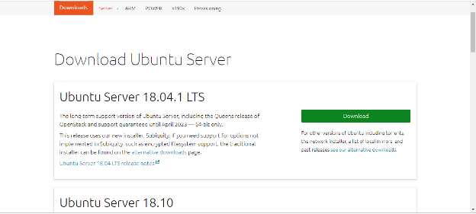

#### 1. Boot into the USB Stick

You need to restart your computer after attaching CD –ROM or pen drive into the computer. Press enter at the time of boot, here select the CD-ROM or pen drive option to start the further boot process. Try for a manual boot setting by holding F12 key to start the boot process. This will allow you to select from various boot options before starting the system. All the options either it is USB or CD ROM or number of [operating systems](https://www.educba.com/features-of-operating-system/) you will get a list from which you need to select one.

**Note:-**

You will see a new screen when your computer boots up called “GNU GRUB”, a boot loader that handles installations for Linux. This screen will only appear in case there is more than one operating system.

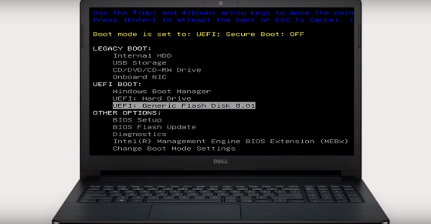

* Set the keyboard layout.
* Now you will be asked What apps would you like to install to start with Linux? The two options are ‘Normal installation’ and ‘Minimal installation’.

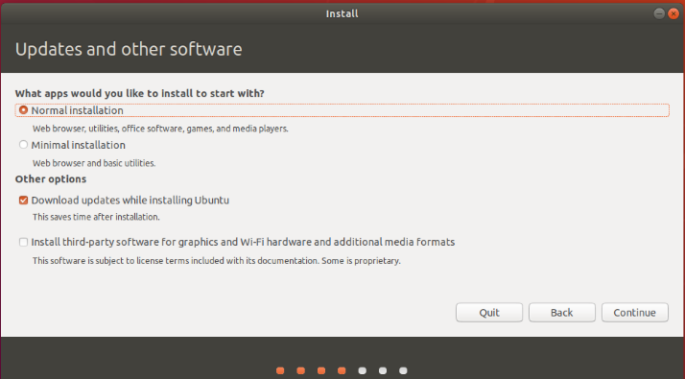

#### 2. Derive Selection

Select the drive for installation of OS to be completed. Select “Erase Disk and [install Ubuntu](https://www.educba.com/install-ubuntu/)” in case you want to replace the existing OS otherwise select “Something else” option and click INSTALL NOW.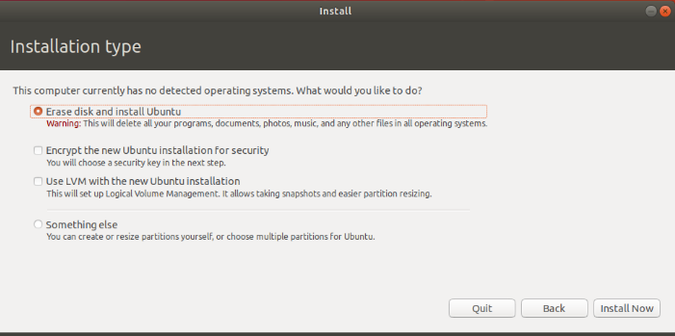

#### 3. Start Installation

* A small panel will ask for confirmation. Click Continue in case you don’t want to change any information provided. Select your location on the map and install Linux.
* Provide the login details.

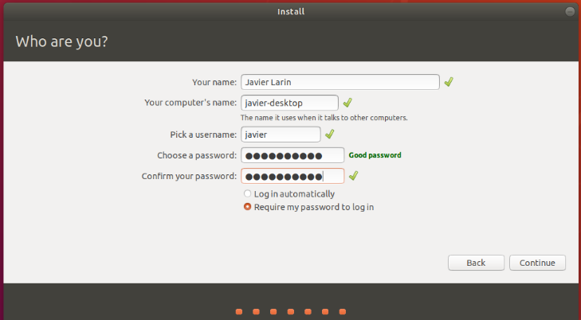

#### 4. Complete the installation process

After the installation is complete you will see a prompt to restart the computer.

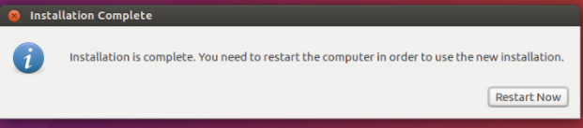

You can also download drivers of your choice through the System Settings menu. Just follow these steps:

Additional Drivers > select the graphics driver from the list.

Many useful drivers will be available in the list, such as Wi-Fi drivers.

There are many other options also available to use and install Linux

### B. Install Linux Using Virtual Box VMWARE

In this way, nothing will affect your Windows operating system.

#### What Are Requirements?

* Good internet connection
* At least 4GB RAM
* At least 12GB of free space

#### Steps:

1. **Download the VIRTUAL BOX from original ORACLE VIRTUAL BOX site. You can refer below link**

https://www.virtualbox.org/

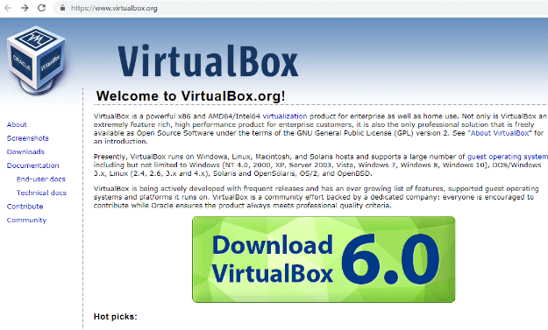

**2. Install Linux Using Virtual Box**

Use the .iso file or ISO file that can be downloaded from the internet and start the virtual box.

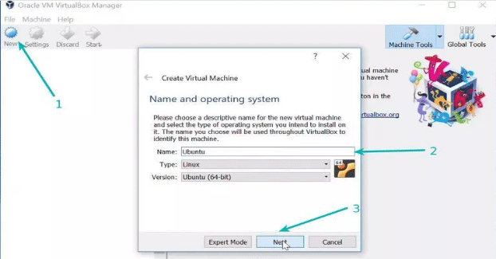

Here we need to allocate RAM to virtual OS. It should be 2 GB as per minimum requirement.

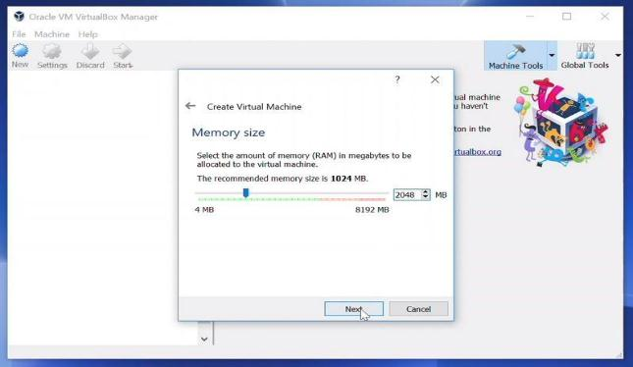

* Choose an option under Create a virtual disk.

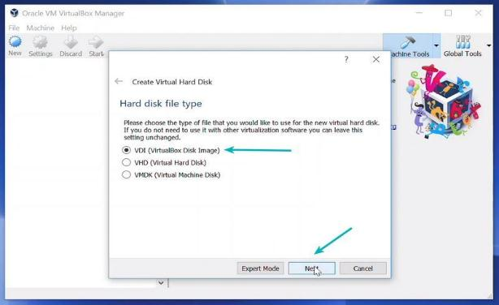

* Choose a type of storage on physical hard disk. And choose the disk size(min 12 GB as per requirement)

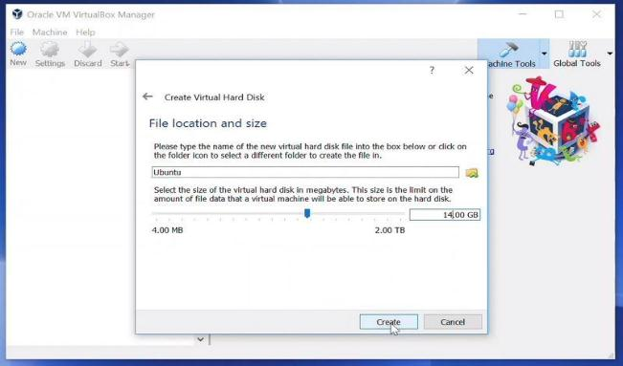

* Click on create option and then click on the START button to start the virtual box and browse to the location of the .iso file of the OS.

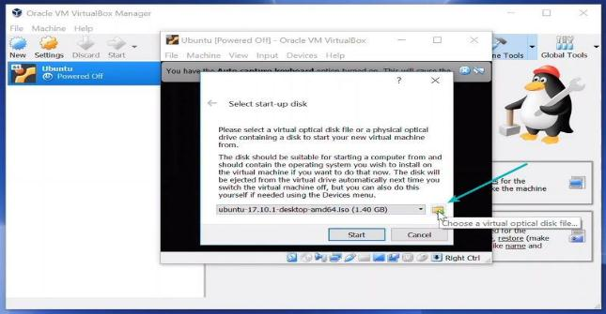

* Now Linux OS will start, Click on install option.

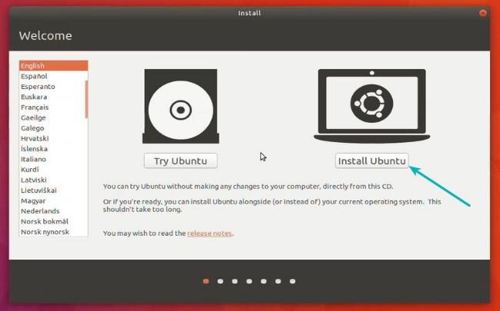

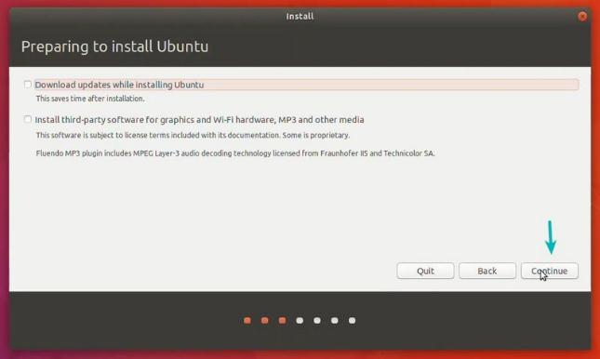

* Select the drive for completing the OS installation. Select “Erase Disk and install Ubuntu” in case you want to replace the existing OS otherwise select “Something else” option and click INSTALL NOW.

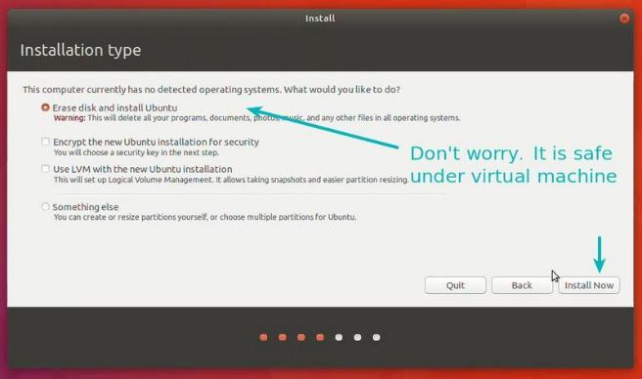

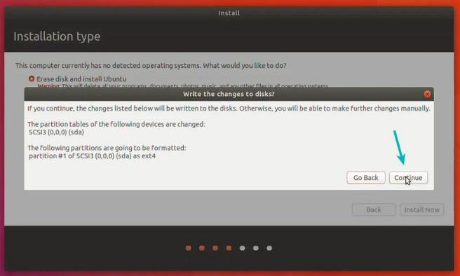

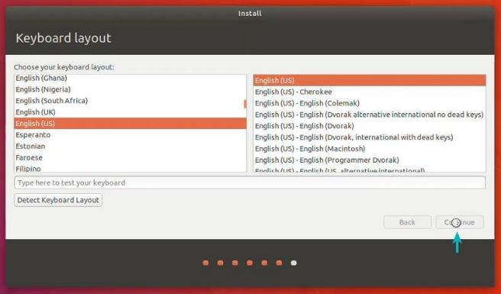

* Click on Continue.
* Choose a username and password.

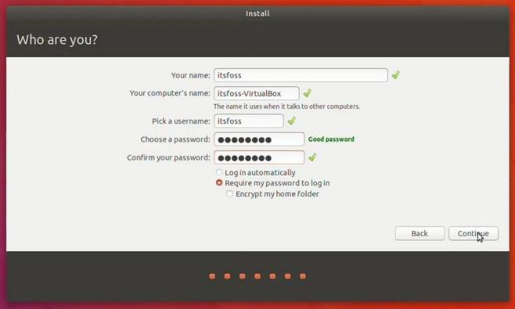

You are almost done. It should take 10-15 minutes to complete the installation. Once the installation finishes, restart the system.

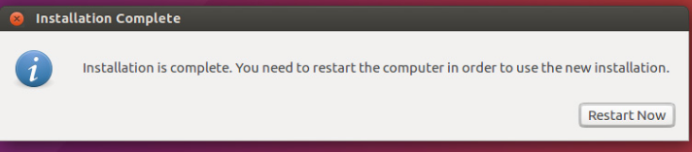

**NOTE**: In case of any issue close and again start the virtual box.

The Linux operating systems now offer millions of programs/applications to choose from, most of them free to install! Linux is also the OS of choice for Server environments due to its stability and reliability (Mega-companies like Amazon, Facebook, and Google use [Linux](https://www.educba.com/linux-alternatives/) for their Servers). It proves to be a good choice for everyone.